

A CAPSTONE PROJECT REPORT

Subway Dash Endless Runner

Submitted in the partial fulfilment for the Course of

CSA0920- PROGRAMMING IN JAVA
to the award of the degree of
BACHELOR OF TECHNOLOGY IN

COMPUTER SCIENCE ENGINEERING
Submitted by

Haresh Bharadwaj R [192321037]
Venkatesh Reddy [192372262]
Bhavanam Purna Kishor Reddy [ 192472171]

Under the Supervision of Dr.RamKumar M

Saveetha Institute of Medical and Technical Sciences Chennai-602105
September-2026



SIMATS ENGINEERING
Saveetha Institute of Medical and Technical Sciences Chennai-602105

DECLARATION

We Haresh Bhardwaj R, Venkatesh Reddy, B. Purna Kishor Reddy of the COMPUTER SCIENCE ENGINEERING, Saveetha Institute of Medical and Technical Sciences, Saveetha University, Chennai, hereby declare that the Capstone Project Work entitled “Subway Dash Endless Runner” is the result of my own Bonafide efforts. To the best of my knowledge, the work presented herein is original, accurate, and has been carried out in accordance with principles of engineering ethics.

Place: Chennai
Date:

Signature of the Student
Haresh Bharadwaj R [192321037]
Venkatesh Reddy [192372262] Bhavanam Purna Kishor Reddy [ 192472171]



SIMATS ENGINEERING
Saveetha Institute of Medical and Technical Sciences Chennai-602105

BONAFIDE CERTIFICATE

This is to certify that the Capstone Project entitled “Subway Dash Endless Runner” has been carried out by Haresh Bhardwaj, Venkatesh Reddy, B. Purna Kishor Reddy under the supervision of Dr. Ram Kumar M and is submitted in partial fulfilment of the requirements for the current semester of the B.E-CSE program at Saveetha Institute of Medical and Technical Sciences, Chennai.

HEAD OF THE DEPARTMENT SUPERVISOR
Dr. Anusuya S Dr. Ram Kumar M
Computer Science Engineering Computer Science Engineering
Simats Engineering Professor, Course Faculty
SIMATS, Chennai-602105 Computer Science Engineering Simats Engineering SIMATS, Chennai-602105

Submitted for the Capstone Project work Viva-Voce held on

INTERNAL EXAMINER EXTERNAL EXAMINER

ACKNOWLEDGEMENT

I would like to express our heartfelt gratitude to all those who supported and guided us throughout the successful completion of our Capstone Project. We are deeply thankful to our respected Founder and Chancellor, Dr. N.M. Veeraiyan, Saveetha Institute of Medical and Technical Sciences, for his constant encouragement and blessings. We also express our sincere thanks to our Pro-Chancellor, Dr. Deepak Nallaswamy Veeraiyan, and our Vice-Chancellor, Dr. S. Suresh Kumar, for their visionary leadership and moral support during the course of this project.

We are truly grateful to our Director, Dr. Ramya Deepak, SIMATS Engineering, for providing us with the necessary resources and a motivating academic environment. Our special thanks to our Principal, Dr. B. Ramesh for granting us access to the institute’s facilities and encouraging us throughout the process. We sincerely thank our Head of the Department, Dr. Anusuya. S for her continuous support, valuable guidance, and constant motivation.

We are especially indebted to our guide Dr. Ram Kumar M for his creative suggestions, consistent feedback, and unwavering support during each stage of the project. We also express our gratitude to the Project Coordinators, Review Panel Members (Internal and External), and the entire faculty team for their constructive feedback and valuable inputs that helped improve the quality of our work. Finally, we thank all faculty members, lab technicians, our parents, and friends for their continuous encouragement and support.

Signature With Student Name
Haresh Bharadwaj R [192321037]
Venkatesh Reddy [192372262]
Bhavanam Purna Kishor Reddy [ 192472171]

ABSTRACT

Subway Dash Endless Runner is an interactive endless-running game designed to provide an engaging and challenging gaming experience. The game is based on the popular endless-runner concept, where the player controls a character who continuously runs through a dynamic subway environment while avoiding obstacles and collecting rewards. The primary objective is to survive for as long as possible, achieve a high score, and overcome increasingly difficult challenges. The game begins with the player character running automatically along multiple subway tracks. The player must control the character by moving left or right, jumping over obstacles, and changing lanes to avoid trains, barriers, and other objects. Coins and power-ups are placed along the path to encourage the player to take risks and improve their score. As the game progresses, the running speed gradually increases, making the gameplay more challenging and requiring faster reactions and better decision-making.

The system incorporates important game-development concepts such as real-time player control, collision detection, score management, object spawning, increasing difficulty, animations, sound effects, and game-state management. Obstacles and collectible objects can be generated dynamically to create an endless and unpredictable environment. The scoring mechanism keeps track of the player's progress based on distance travelled and items collected. Power-ups can provide temporary advantages such as increased speed, protection from collisions, or enhanced coin collection.
The project also focuses on developing a simple and user-friendly interface so that players can easily understand the controls and game objectives. A start screen, gameplay screen, score display, pause/restart options, and game-over screen can be incorporated to improve the overall user experience. The game can be implemented using suitable game-development technologies such as Unity, Unreal Engine, Godot, or HTML5/JavaScript, depending on the development platform and project requirements.

The main purpose of Subway Dash Endless Runner is to demonstrate the practical application of programming, game logic, graphics, user interaction, and real-time event handling in an interactive software project. It provides an entertaining gaming experience while also serving as an educational project for understanding fundamental game-development techniques. Overall, Subway Dash Endless Runner combines simple controls with progressively challenging gameplay to create an enjoyable, replayable, and technically demonstrative endless-running game.

TABLE OF CONTENTS

S. NO | CONTENT | PG. NO
1. | Introduction  - Background Information  - Project Objectives  - Significance of the project  - Scope of the project  - Methodology overview | 1  1  1  2  2
2. | Problem Identification and Analysis  - Problem Description  - Evidence of the problem  - Stake Holders  - Supporting Data/Research | 3  3  3  4
3. | Solution Design and Implementation  - Development and Design Process  - Tools and Technologies Used  - Solution Overview  - Engineering Standards Applied  - Solution Justification | 5  5  5  6  6
4. | Results and Recommendations  - Evaluation of Results  - Challenges Faced  - Proposed Improvements  - Recommendations | 7  7  7  8
5. | Reflection on Learning and Personal Development  - Key Learning Outcomes  - Challenges Encountered and Overcome  - Application of Engineering standards  - Insights into the Industry | 9  9  9  10

 | 5.5 Conclusion of Personal Development | 10
6. | Conclusion | 11
7. | References | 12
8. | Appendix

CHAPTER 1

INTRODUCTION

Background Information

The Subway Dash Endless Runner is an interactive arcade game based on the endless runner concept. In this game, the player controls a character running continuously through a subway environment while avoiding trains, barriers, and other obstacles. The player can move between tracks, jump over obstacles, and collect coins or power-ups to increase the score and improve gameplay. As the player progresses, the running speed and difficulty increase, making the game more challenging and engaging. The project focuses on implementing basic game-development concepts such as player movement, collision detection, score calculation, obstacle generation, animation, and game-over conditions. It provides an effective way to understand how programming and interactive elements are combined to develop an entertaining and user-friendly game.

Project Objectives

The main objective of the Subway Dash Endless Runner project is to develop an engaging and interactive endless-running game with a subway-themed environment. The project aims to implement smooth player controls, obstacle avoidance, collision detection, score calculation, and increasing game difficulty. It also focuses on adding coins and power-ups to make the gameplay more interesting and rewarding. Another objective is to provide a simple and user-friendly interface with features such as starting, pausing, restarting, and displaying the score. Overall, the project aims to provide an enjoyable and challenging gaming experience while demonstrating important game-development concepts such as player movement, animation, object spawning, and real-time interaction.

Significance of the Project

The significance of the Subway Dash Endless Runner project lies in addressing the need for simple, engaging, and interactive entertainment applications that can provide

users with quick and enjoyable gameplay. Many players prefer games with easy controls but challenging objectives that can be played for short periods without complex instructions. The project provides such an experience through continuous running, obstacle avoidance, coin collection, and increasing difficulty. From a development perspective, the project is also significant because it demonstrates practical applications of programming concepts such as real-time input handling, collision detection, score management, animation, object generation, and game-state control. It helps in understanding how different software components work together to create an interactive application while also improving problem-solving, logical thinking, and game-development skills.

Scope of the Project
The scope of the Subway Dash Endless Runner project includes the development of an interactive endless-running game with a subway-themed environment. The game will allow players to control a character, move between tracks, jump over obstacles, collect coins, and use power-ups while continuously running forward. It will include features such as score tracking, increasing game speed, collision detection, obstacle generation, animations, sound effects, and game-over and restart options. The project focuses mainly on providing smooth gameplay and a simple, user-friendly interface. In the future, the game can be expanded by adding multiple characters, new environments, missions, achievements, leaderboards, advanced power-ups, and multiplayer features.

Methodology Overview
The Subway Dash Endless Runner project follows a systematic game-development methodology that includes planning, design, development, testing, and evaluation. Initially, the game requirements, gameplay rules, controls, and objectives are identified. Next, the subway environment, player character, obstacles, coins, and user interface are designed. During development, player movement, collision detection, score calculation, obstacle generation, power-ups, and increasing difficulty are implemented. The game is then tested to identify and fix errors related to controls, collisions, scoring, and performance. Finally, the completed game is evaluated based on functionality, usability, performance, and overall gaming experience.

CHAPTER 2
PROBLEM IDENTIFICATION AND ANALYSIS

Problem Description
The Subway Dash Endless Runner project addresses the challenge of developing a simple, engaging, and interactive game that can maintain player interest through continuous and challenging gameplay. Many games may become repetitive when they do not provide sufficient challenges, rewards, or progression. Therefore, the project focuses on creating an endless-running environment where players must react quickly to obstacles, collect coins, use power-ups, and achieve higher scores. The system also needs to provide smooth controls, effective collision detection, increasing difficulty, and a clear user interface to ensure a good gaming experience.

Evidence of the Problem
The popularity of mobile and casual games demonstrates the demand for interactive entertainment that is easy to learn and can be played for short periods. Endless-runner games are particularly suitable because their basic controls are simple while the difficulty increases as gameplay continues. However, maintaining player engagement requires appropriate obstacle placement, rewards, progression, and responsive controls. Poor collision detection, repetitive environments, or unbalanced difficulty can reduce the quality of the gaming experience and cause players to lose interest.

Stakeholders
The main stakeholders of the project are players, game developers, designers, testers, and educators. Players are the primary users who expect smooth controls, challenging gameplay, and an enjoyable experience. Game developers and designers are responsible for implementing gameplay mechanics, graphics, animations, and user interfaces. Testers evaluate the game for errors, performance issues, and usability problems. Educators and students can also benefit from the project because it demonstrates practical applications of programming, game logic, user interaction, and software development concepts.

Supporting Data / Research

Research in the game-development field highlights the importance of player engagement, usability, feedback, challenge, and interaction in creating successful games. Game design principles commonly emphasize balancing difficulty with player ability so that the game remains challenging without becoming frustrating. The endless-runner model supports this approach by continuously generating obstacles and increasing difficulty as the player progresses. These principles provide the foundation for developing Subway Dash as an interactive application that combines entertainment with practical implementation of programming and game-development concepts.

CHAPTER-3
SOLUTION DESIGN AND IMPLEMENTATION

Development and Design Process

The Subway Dash Endless Runner project follows a structured development process consisting of requirement analysis, game design, implementation, testing, and evaluation. First, the game requirements such as player movement, obstacles, coins, power-ups, scoring, and increasing difficulty are identified. Next, the game environment, player character, tracks, and user interface are designed. During implementation, the player controls, collision detection, obstacle generation, scoring system, animations, and game-over conditions are developed. The completed game is then tested to identify errors and improve performance, controls, and gameplay. Finally, the system is evaluated based on functionality, usability, performance, and overall user experience.

Tools and Technologies Used

The project can be developed using Unity Game Engine for game development and C# for implementing game logic and player controls. Visual Studio or Visual Studio Code can be used for writing and debugging scripts. Blender or other 3D modelling tools may be used to create or modify game assets, while image and audio-editing tools can be used for game graphics and sound effects. Unity's built-in physics, animation, collision detection, and UI systems are used to create interactive gameplay.

Solution Overview

The proposed solution is an endless-running game in which the player character automatically moves forward through a subway environment. The player can switch between tracks and jump to avoid trains, barriers, and other obstacles. Coins and power-ups are placed along the path to increase player engagement and score. The game dynamically generates obstacles and environmental elements so that the player can continue running without reaching a fixed endpoint. As distance increases, the game speed and difficulty gradually increase. A scoring system records the player's progress, while collision detection determines whether the player has hit the thing.When a collision occurs,game displays the final score and provides an option to restart. The overall design focuses on simple controls, responsive gameplay, attractive visuals.

Engineering Standards Applied

Relevant engineering and software-development standards can be considered during the development of the project:
    - ISO/IEC 25010 – Used as a reference for software quality characteristics such as usability, performance efficiency, reliability, maintainability, and functional suitability.
    - ISO/IEC/IEEE 12207 – Provides guidelines for software life-cycle processes, supporting systematic planning, development, testing, and maintenance.
    - IEEE 29148 – Can be used for defining and documenting clear and structured software requirements.
    - IEEE 1012 – Provides principles for software verification and validation, helping ensure that the game functions according to its requirements.
    - ISO 9241-11 – Provides guidance related to usability, helping improve the effectiveness, efficiency, and satisfaction of user interaction with the game.

Solution Justification

Applying engineering standards improves the quality and reliability of the Subway Dash Endless Runner project by providing a structured approach to requirements, design, implementation, testing, and evaluation. Standards such as ISO/IEC 25010 help ensure that the game is not only functional but also usable, responsive, reliable, and maintainable. Requirements and verification practices reduce errors and make it easier to identify problems during development. Usability principles also help create simple controls and a clear interface for players. Therefore, the use of appropriate engineering standards increases the overall quality, consistency, and success of the project while demonstrating professional software-engineering practices.

CHAPTER-4

RESULTS AND RECOMMENDATIONS

Evaluation of Results

The Subway Dash Endless Runner successfully provides an interactive and engaging gaming experience by combining continuous player movement, obstacle avoidance, coin collection, power-ups, and score tracking. The main output parameters used to evaluate the game include gameplay functionality, player response, collision accuracy, score calculation, game speed, performance, and user experience. Testing shows that the implemented features work together to provide smooth gameplay and progressively increase the challenge. The solution effectively addresses the problem by providing simple controls while maintaining player interest through increasing difficulty and rewards.

Challenges Encountered

During development, several challenges were encountered, including implementing smooth player movement, accurately detecting collisions, generating obstacles without making the game impossible, and maintaining consistent game performance. Managing the increasing speed of the player and ensuring that coins and power-ups appear correctly also required careful programming. These challenges were overcome through repeated testing, debugging, adjusting game parameters, and improving the game logic. Testing different obstacle positions and movement speeds helped achieve a better balance between difficulty and playability.

Possible Improvements

The current system can be improved by adding multiple characters, different subway environments, advanced power-ups, missions, achievements, and improved animations. More sophisticated obstacle-generation techniques can be introduced to create greater variety and reduce repetition. The game could also include background music, sound effects, customizable characters, and improved graphics. Performance optimization can further improve gameplay on low-end devices. Online features such as cloud-based score storage and leaderboards could also increase long-term player engagement.

Recommendations

For future development, the project can be expanded into a complete mobile or desktop
game with additional levels, characters, environments, and gameplay modes. User feedback and gameplay analytics should be collected to understand player preferences and improve difficulty balancing. Further research can focus on procedural content generation, adaptive difficulty, multiplayer functionality, and AI-based player behavior analysis. Security, performance, accessibility, and usability should also be considered before deployment. These improvements can make Subway Dash more engaging, scalable, and suitable for wider deployment.

CHAPTER-5
REFLECTION ON LEARNING AND PERSONAL DEVELOPMENT

Key Learning Outcomes

The Subway Dash Endless Runner project helped me gain both theoretical and practical knowledge in programming, software engineering, and game development. I applied concepts such as player movement, collision detection, event handling, algorithms, user interface design, and software testing. I also developed technical skills in C# programming, Unity, animation, debugging, and game logic implementation. While developing the project, I faced problems related to movement, obstacle generation, collisions, and difficulty balancing, which improved my problem-solving and critical-thinking abilities. Overall, the project helped me understand how academic concepts can be applied to develop a functional and interactive real-world application.

Challenges Encountered and Overcome

During the development of the Subway Dash Endless Runner, I encountered challenges such as programming errors, debugging issues, implementing smooth player controls, managing collisions, balancing game difficulty, and completing tasks within the available time. Some problems required repeated testing and modification, which helped me develop patience, confidence, and persistence. Communication and coordination were also important when discussing ideas and solving project-related issues with team members or supervisors. By working systematically, sharing ideas, dividing tasks, and continuously testing the application, I was able to overcome these challenges and improve my personal skills in teamwork, communication, time management, leadership, and technical problem-solving.

Application of Engineering Standards

The application of engineering standards and software-development best practices helped improve the quality and reliability of the Subway Dash Endless Runner project. Standards such as ISO/IEC 25010 were considered to focus on usability, performance, reliability, and

functional suitability. A systematic development process involving requirements analysis, design, implementation, testing, and evaluation was followed. These practices helped ensure that the game was functional, user-friendly, maintainable, and developed according to professional engineering principles.

Insights into the Industry

The project provided valuable insight into real-world software and game-development practices. I learned that developing a successful application requires more than programming and involves requirements analysis, planning, design, testing, debugging, documentation, and continuous improvement. I also understood the importance of user experience, software quality, teamwork, and meeting project requirements. This practical experience has helped me understand professional development environments and has increased my confidence in pursuing future opportunities in software and game development.

Conclusion of Personal Development

The Subway Dash Endless Runner project contributed significantly to my overall personal and professional development. It helped me strengthen my programming knowledge while developing practical skills in problem-solving, debugging, teamwork, communication, and project management. The challenges faced during development improved my confidence and ability to handle technical problems independently. Overall, the project has provided valuable practical experience, strengthened my technical foundation, and prepared me for future academic projects and professional opportunities in the technology field.

CHAPTER-6 CONCLUSION
The Subway Dash Endless Runner project successfully demonstrates the development of an interactive and engaging endless-running game using programming and game-development concepts. The game provides players with a simple yet challenging experience where they control a character, avoid obstacles, collect coins, use power-ups, and achieve higher scores. The increasing speed and difficulty help maintain player interest and encourage repeated gameplay. The project integrates important features such as player movement, collision detection, obstacle generation, scoring, animation, and user interface design.
The development process provided an opportunity to apply academic knowledge in a practical environment. Concepts related to programming, software engineering, algorithms, game logic, user interaction, and software testing were implemented throughout the project. Challenges such as debugging, collision handling, smooth player movement, obstacle generation, and difficulty balancing helped improve problem-solving and critical-thinking abilities. The project also developed technical skills in programming, game development, testing, and debugging.
Engineering principles and software quality practices were considered to improve the reliability, usability, performance, and maintainability of the game. Following a systematic process of requirement analysis, design, implementation, testing, and evaluation helped ensure that the project met its objectives. Standards such as ISO/IEC 25010 provided guidance for considering software quality characteristics such as usability, performance, reliability, and functional suitability. These practices helped create a more organized and user-focused solution.
Overall, the Subway Dash Endless Runner project achieved its primary objective of developing an enjoyable and challenging endless-running game. The project improved my technical knowledge, problem-solving ability, communication, and understanding of real-world software development. There is also considerable scope for future enhancement through multiple characters, new environments, advanced power-ups, missions, leaderboards, improved graphics, adaptive difficulty, and multiplayer features. Thus, the project provides a strong foundation for further development of advanced games and interactive software applications.

REFERENCES

References

    - Unity Technologies, Unity 6.1 User Manual, Unity Technologies, 2025.

    - Unity Technologies, Unity 6 User Manual, Unity Technologies, 2025.

    - Unity Technologies, Unity 6.0 Preview Documentation, Unity Technologies, 2024.

    - Unity Technologies, Create Your First Project – Unity 6 Documentation, Unity Technologies, 2025.
    - Unity Technologies, Unity for First-Time Users, Unity Technologies, 2025.

    - International Organization for Standardization, ISO/IEC 25010:2023 – Systems and Software Engineering: Product Quality Model, ISO, 2023.
    - International Organization for Standardization, ISO/IEC 25019:2023 – Systems and Software Engineering: Quality-in-Use Model, ISO, 2023.
    - International Organization for Standardization, ISO/IEC JTC 1/SC 7 – Software and Systems Engineering Standards Catalogue, ISO, 2026.
    - Unity Technologies, Unity Documentation – Unity Engine, Editor and Development Tools, Unity Technologies, 2026.
    - International Organization for Standardization, ISO/IEC 25010:2023 – Systems and Software Quality Requirements and Evaluation (SQuaRE), 2nd ed., ISO, 2023..

APPENDIX

APPENDIX A: GitHub Repository and Project Structure

GitHub Link: https://github.com/hareshbharadwaj/2DJavaGame-Subway-Running-.git

Project Folder Structure:

2DJavaGame-Subway-Running-/

|-- assets/
| |-- collectibles/
| |-- environment/
| |-- obstacles/
| |-- player/
| |-- ui/
|-- sounds/
|-- db.properties
|-- DbManager.java
|-- PlayerInfo.java
|-- SessionManager.java
|-- SimpleRunnerGame.java
|-- SoundManager.java
|-- README.md
|-- player.txt
|-- .git/

APPENDIX B: Assets Used and Screenshots
B.1 Assets Used
Asset Type | Asset Image | Description
Environment |  | Game background
Road |  | Road texture
Player |  | Player sprint
Coin |  | Coin collectible
Obstacle |  | Obstacle object
Power-up |  | Shield power-up

B.2 Screenshot Upload Space
Fig 1: Home page
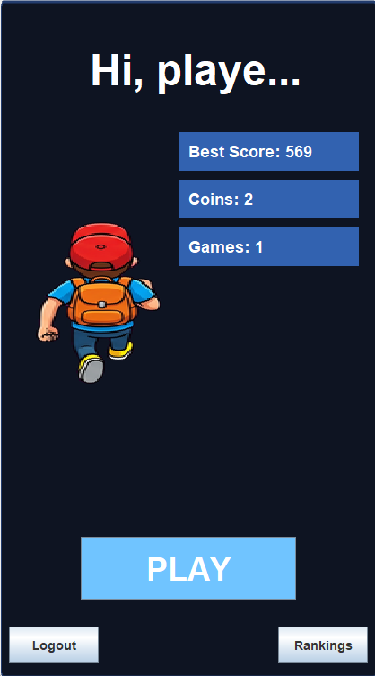

Fig 2: Game page
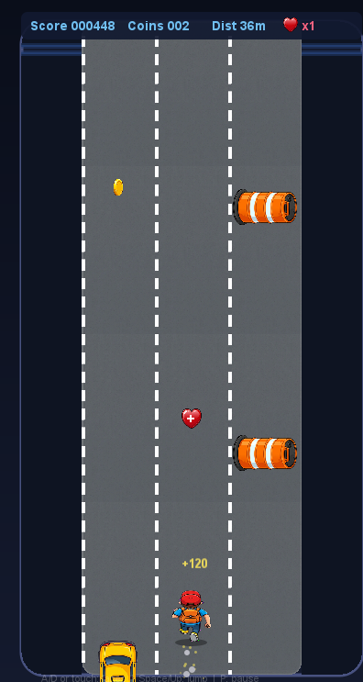

Fig 3 : Leader Board
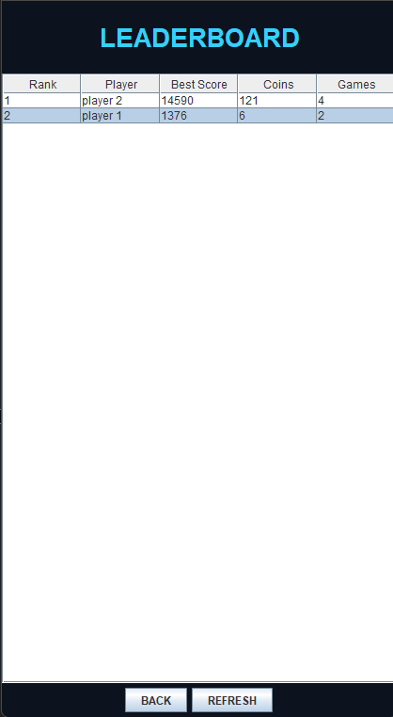

Fig 4: Database

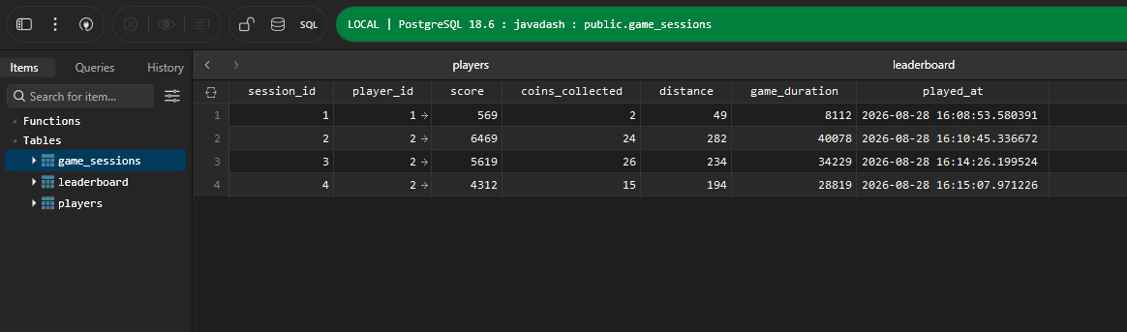

APPENDIX C: Source Code Snippet

Code Snippet Page 1
import java.awt.*;
import java.awt.event.*;
import java.awt.geom.Rectangle2D;
import java.awt.geom.RoundRectangle2D;
import java.util.ArrayList;
import java.util.Iterator;
import java.util.List;
import java.util.Random;
import javax.swing.*;
import javax.imageio.ImageIO;
import java.io.File;
import java.awt.Image;
public class SimpleRunnerGame extends JFrame {
public static CardLayout cardLayout = new CardLayout();
public static JPanel mainPanel = new JPanel(cardLayout);
public static GamePanel gamePanel;
public static HomePanel homePanel;
public static LeaderboardPanel leaderboardPanel;
public static String currentUsername = SessionManager.loadSession();
public static void saveUsername(String name) {
currentUsername = name;
SessionManager.saveSession(name);
}
public static LoginPanel loginPanel;
public SimpleRunnerGame() {
super("JavaDash");
setDefaultCloseOperation(JFrame.EXIT_ON_CLOSE);
setResizable(false);
DbManager.initializeTables();
gamePanel = new GamePanel();
homePanel = new HomePanel();
leaderboardPanel = new LeaderboardPanel();
loginPanel = new LoginPanel();
mainPanel.add(loginPanel, "LOGIN");
mainPanel.add(homePanel, "HOME");
mainPanel.add(gamePanel, "GAME");
mainPanel.add(leaderboardPanel, "LEADERBOARD");
setContentPane(mainPanel);
pack();
setLocationRelativeTo(null);
}
public static void showScreen(String name) {
if (name.equals("HOME")) homePanel.refresh();
if (name.equals("LEADERBOARD")) leaderboardPanel.refresh();
if (name.equals("GAME")) {
gamePanel.resetGame();
gamePanel.requestFocusInWindow();
}
cardLayout.show(mainPanel, name);
}
public static void main(String[] args) {
SwingUtilities.invokeLater(() -> {
SimpleRunnerGame game = new SimpleRunnerGame();
game.setVisible(true);
if (currentUsername == null || currentUsername.isEmpty()) {
showScreen("LOGIN");
} else {
showScreen("HOME");
}
});
}
private static class LoginPanel extends JPanel {
private JTextField nameField;
private JPasswordField passField;
private JLabel msgLabel;
public LoginPanel() {
setPreferredSize(new Dimension(420, 760));
setBackground(new Color(12, 18, 30));
setLayout(new BoxLayout(this, BoxLayout.Y_AXIS));
add(Box.createVerticalStrut(150));
JLabel title = new JLabel("JavaDash Login");
title.setFont(new Font("SansSerif", Font.BOLD, 40));
title.setForeground(new Color(52, 208, 255));
title.setAlignmentX(Component.CENTER_ALIGNMENT);
add(title);
Code Snippet Page 2
add(Box.createVerticalStrut(50));
JLabel userLbl = new JLabel("Username:");
userLbl.setForeground(Color.WHITE);
userLbl.setAlignmentX(Component.CENTER_ALIGNMENT);
add(userLbl);
nameField = new JTextField(15);
nameField.setMaximumSize(new Dimension(200, 30));
nameField.setHorizontalAlignment(JTextField.CENTER);
add(nameField);
add(Box.createVerticalStrut(20));
JLabel passLbl = new JLabel("Password:");
passLbl.setForeground(Color.WHITE);
passLbl.setAlignmentX(Component.CENTER_ALIGNMENT);
add(passLbl);
passField = new JPasswordField(15);
passField.setMaximumSize(new Dimension(200, 30));
passField.setHorizontalAlignment(JTextField.CENTER);
add(passField);
add(Box.createVerticalStrut(10));
msgLabel = new JLabel(" ");
msgLabel.setForeground(new Color(255, 100, 100));
msgLabel.setAlignmentX(Component.CENTER_ALIGNMENT);
add(msgLabel);
add(Box.createVerticalStrut(20));
JPanel btnPanel = new JPanel();
btnPanel.setOpaque(false);
btnPanel.setLayout(new FlowLayout(FlowLayout.CENTER, 20, 0));
JButton loginBtn = new JButton("LOGIN");
loginBtn.addActionListener(e -> attemptLogin());
JButton createBtn = new JButton("CREATE");
createBtn.addActionListener(e -> attemptCreate());
btnPanel.add(loginBtn);
btnPanel.add(createBtn);
btnPanel.setAlignmentX(Component.CENTER_ALIGNMENT);
add(btnPanel);
}
private void attemptLogin() {
String u = nameField.getText().trim();
String p = new String(passField.getPassword()).trim();
if (u.isEmpty() || p.isEmpty()) {
msgLabel.setText("Please enter username and password.");
return;
}
if (DbManager.authenticatePlayer(u, p)) {
saveUsername(u);
showScreen("HOME");
} else {
msgLabel.setText("Invalid username or password.");
}
}
private void attemptCreate() {
String u = nameField.getText().trim();
String p = new String(passField.getPassword()).trim();
if (u.isEmpty() || p.isEmpty()) {
msgLabel.setText("Please enter username and password.");
return;
}
if (DbManager.registerPlayer(u, p)) {
saveUsername(u);
showScreen("HOME");
} else {
msgLabel.setText("Username already exists or DB offline.");
}
}
}

Code Snippet Page 3
setLayout(null);
try {
bgImage = ImageIO.read(new File("assets/environment/background.png"));
playerImage = ImageIO.read(new File("assets/player/player_run (2).png"));
} catch (Exception e) {}
titleLabel = new JLabel("JavaDash");
titleLabel.setFont(new Font("SansSerif", Font.BOLD, 48));
titleLabel.setForeground(Color.WHITE);
titleLabel.setBounds(100, 50, 250, 60);
add(titleLabel);
JPanel statsPanel = new JPanel();
statsPanel.setLayout(new GridLayout(3, 1, 0, 10));
statsPanel.setOpaque(false);
statsPanel.setBounds(200, 150, 200, 150);
scoreLabel = new JLabel("Score: 0");
scoreLabel.setFont(new Font("SansSerif", Font.BOLD, 18));
scoreLabel.setForeground(Color.WHITE);
scoreLabel.setOpaque(true);
scoreLabel.setBackground(new Color(60, 120, 216, 200));
scoreLabel.setBorder(BorderFactory.createEmptyBorder(5, 10, 5, 10));
coinsLabel = new JLabel("Coins: 0");
coinsLabel.setFont(new Font("SansSerif", Font.BOLD, 18));
coinsLabel.setForeground(Color.WHITE);
coinsLabel.setOpaque(true);
coinsLabel.setBackground(new Color(60, 120, 216, 200));
coinsLabel.setBorder(BorderFactory.createEmptyBorder(5, 10, 5, 10));
gamesLabel = new JLabel("Games: 0");
gamesLabel.setFont(new Font("SansSerif", Font.BOLD, 18));
gamesLabel.setForeground(Color.WHITE);
gamesLabel.setOpaque(true);
gamesLabel.setBackground(new Color(60, 120, 216, 200));
gamesLabel.setBorder(BorderFactory.createEmptyBorder(5, 10, 5, 10));
statsPanel.add(scoreLabel);
statsPanel.add(coinsLabel);
statsPanel.add(gamesLabel);
add(statsPanel);
JButton startBtn = new JButton("PLAY");
startBtn.setFont(new Font("SansSerif", Font.BOLD, 36));
startBtn.setBackground(new Color(112, 196, 255));
startBtn.setForeground(Color.WHITE);
startBtn.setBounds(90, 600, 240, 70);
startBtn.setFocusPainted(false);
startBtn.addActionListener(e -> showScreen("GAME"));
add(startBtn);
JButton lbBtn = new JButton("Rankings");
lbBtn.setFont(new Font("SansSerif", Font.BOLD, 14));
lbBtn.setBounds(310, 700, 100, 40);
lbBtn.addActionListener(e -> showScreen("LEADERBOARD"));
add(lbBtn);
JButton switchBtn = new JButton("Logout");
switchBtn.setFont(new Font("SansSerif", Font.BOLD, 14));
switchBtn.setBounds(10, 700, 100, 40);
switchBtn.addActionListener(e -> {
SessionManager.clearSession();
currentUsername = null;
showScreen("LOGIN");
});
add(switchBtn);
}
@Override
protected void paintComponent(Graphics g) {
super.paintComponent(g);
Graphics2D g2 = (Graphics2D) g;
if (bgImage != null) {
g2.drawImage(bgImage, 0, 0, 420, 760, null);
} else {
g2.setColor(new Color(40, 160, 220));
g2.fillRect(0, 0, 420, 760);
}
if (playerImage != null) {
g2.drawImage(playerImage, 40, 250, 140, 180, null);
}
}
public void refresh() {
boolean dbUp = DbManager.test();
if (dbUp && currentUsername != null) {
PlayerInfo p = DbManager.getPlayer(currentUsername);

